**Development Environment and Norm**

File encodings

1. IDE encoding:UTF-8
2. Project encoding:UTF-8
3. Properties files encoding:UTF-8

Naming convention

1. Follow basic android naming convention(link:

<https://android.jlelse.eu/java-coding-standards-ee1687a82ec2> )

1. Class Naming

Activity class uses Activity as a suffix, such as: LoginActivity

Fragment class uses Fragment as a suffix, such as: ShareDialogFragment

Service class uses with Service as a suffix, such as: DownloadService

Adapter class uses Adapter as a suffix, such as: CouponListAdapter

Tool class uses Util as a suffix, such as: EncryptUtil

Model class uses BO as a suffix, such as: CouponBO

Interface implementation class uses Impl as a suffix, such as: ApiImpl

1. Method Naming

Initialization method, prefix:init, example: initView

button click method, prefix:to, example: toLogin

setting method, prefix:set, example: setData

get method, prefix:get, example: getData

asynchronously loading method, prefix:load, example: loadData

judgement method , prefix: is or has, or a word with logical meaning such as equals, example: isEmpty

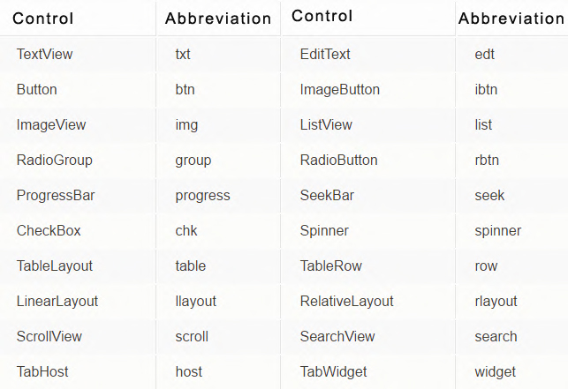

TOOLS and FRAMEWORK (version of framework will be specific by Maven or Gradle)

1.

JDK: jdk Version: 1.8.0_131

IDE: android studio Version: 3.0.1

Version of JDK and IDE can be discussed and changed after tomorrow’s meeting.

2.

Continuous integration: Jenkins(we may need a server…)

Version control: github

Dependency injection: butter knife

Security API: OWASP Enterprise Security API

Build management: Gradle (need learn Grovvy ) , or Maven

Database ORM: ORMLite

Json: Gson, GsonFormat

Logging: Timber

UI test: UiAutomator

Unit test: junit、 mockito、 robolectric